Black Bisexual Experience Handout
Bisexual is a Community Identity Label (similar to “lesbian,” “gay,” “straight,” or “queer”). Simplest definition of bisexual? People with the capacity to be attracted to more than one gender.
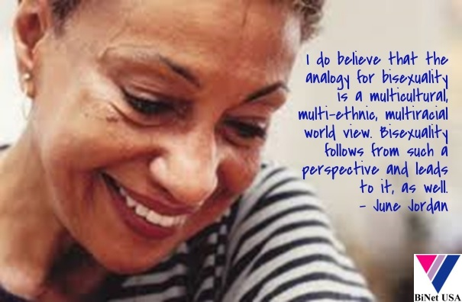
Many bisexuals use Personal Identity Labels that serve a vital function in describing differences while giving each individual a space to be unique.
Personal Identity Labels can include (but would never be limited to): fluid, multisexual, non-monosexual, pansexual, polysexual, pomosexual, and omnisexual.
MOST SURVEYS SHOW THE BISEXUAL COMMUNITY TO BE 40-51% OF THE LGBT COMMUNITY.
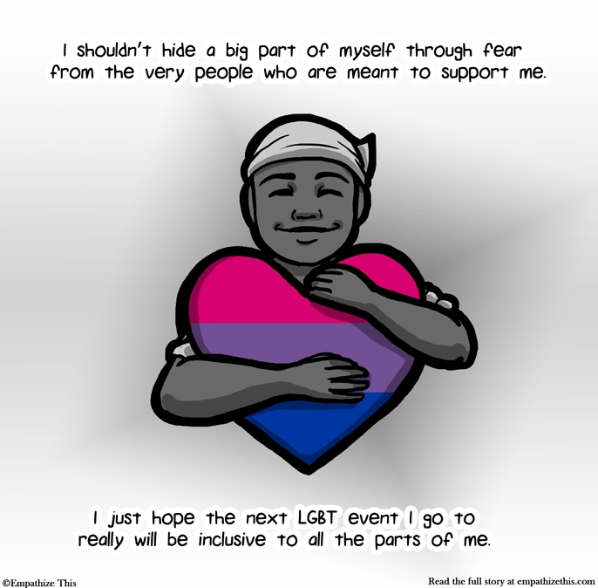
According to a 2009 Human Rights Campaign study, 40% of bisexual identified people ALSO identify as people of color.
The bisexual “coming out experience:
- More stages than the gay/lesbian coming out
- Coming out later in life is more norm
- Final stage is different and includes continued “identity maintenance
Black Bisexual Resources
- Bi Groups In The U.S. Map & Contact Info
http://www.binetusa.org/bi-groups-in-the-us
- BiNet USA’s Black Bisexual Collective (BBC*) email list.
https://groups.google.com/a/binetusa.org/forum/#!forum/bbc
- Bisexual Resource Center
www.biresource.net

*Bisexual is used as an inclusive term to mean romantic and/or sexual attraction to more than one gender, and includes pansexual, fluid, omnisexual, and queer self-identifications.

